ATMEGA328P-PU Microcontroller: CAD Models, Datasheet, Features [Video&FAQ]

Catalog
Product Overview
ATMEGA328P-PU Related Video Introduction
ATMEGA328P-PU CAD Models
ATMEGA328P-PU Pin Configuration
ATMEGA328P-PU Block Diagram
ATMEGA328P-PU Features
ATMEGA328P-PU Datasheet
ATMEGA328P-PU Specifications
ATMEGA328P-PU Manufacturer
Using Warning
ATMEGA328P-PU FAQ

Product Overview
The ATmega48A/PA/88A/PA/168A/PA/328/P is a low power, CMOS 8-bit microcontrollers based on the AVR® enhanced RISC architecture. By executing instructions in a single clock cycle, the devices achieve CPU throughput approaching one million instructions per second (MIPS) per megahertz, allowing the system designer to optimize power consumption versus processing speed.

ATMEGA328P-PU Related Video Introduction
https://www.youtube.com/watch?v=npc3uzEVvc0
ATMEGA328P-PU Video Description: Arduino Uno (ATMEGA328P) on a breadboard Tutorial DIY project. Easy guide.

In this video, we are going to build an Arduino Uno clone in a breadboard using only 5 parts.

ATMEGA328P-PU CAD Models
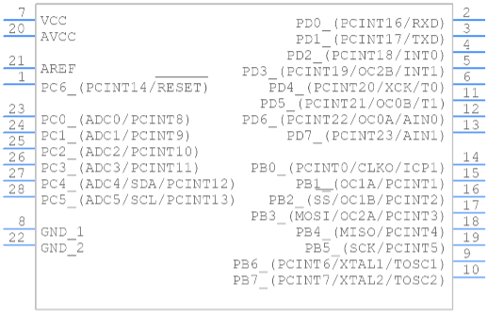
Figure: ATMEGA328P-PU PCB Symbol

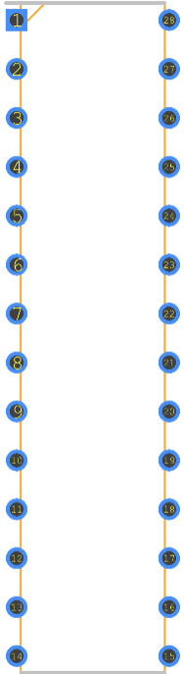
Figure: ATMEGA328P-PU Footprint

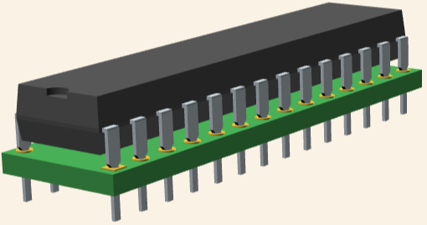
Figure: ATMEGA328P-PU 3D Models

ATMEGA328P-PU Pin Configuration
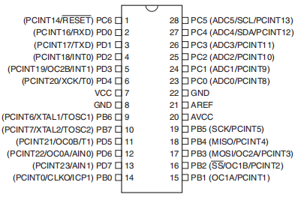
Figure: ATMEGA328P-PU Pin Configuration

ATMEGA328P-PU Block Diagram
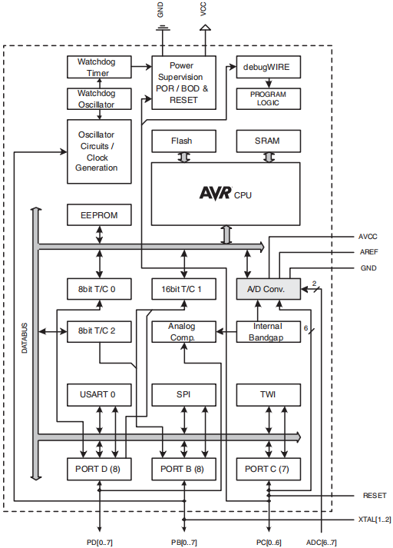
Figure: ATMEGA328P-PU Block Diagram

ATMEGA328P-PU Features
- High Performance, Low Power AVR® 8-Bit Microcontroller Family
- Advanced RISC Architecture
̶ 131 Powerful Instructions – Most Single Clock Cycle Execution
̶ 32 x 8 General Purpose Working Registers
̶ Fully Static Operation
̶ Up to 20 MIPS Throughput at 20MHz
̶ On-chip 2-cycle Multiplier
- High Endurance Non-volatile Memory Segments
̶ 4/8/16/32KBytes of In-System Self-Programmable Flash program memory
̶ 256/512/512/1KBytes EEPROM
̶ 512/1K/1K/2KBytes Internal SRAM
̶ Write/Erase Cycles: 10,000 Flash/100,000 EEPROM
̶ Data retention: 20 years at 85°C/100 years at 25°C(1)
̶ Optional Boot Code Section with Independent Lock Bits
● •In-System Programming by On-chip Boot Program
● •True Read-While-Write Operation
̶ Programming Lock for Software Security
- QTouch® library support
̶ Capacitive touch buttons, sliders and wheels
̶ QTouch and QMatrix™ acquisition
̶ Up to 64 sense channels
- Peripheral Features
̶ Two 8-bit Timer/Counters with Separate Prescaler and Compare Mode
̶ One 16-bit Timer/Counter with Separate Prescaler, Compare Mode, and Capture Mode
̶ Real Time Counter with Separate Oscillator
̶ Six PWM Channels
̶ 8-channel 10-bit ADC in TQFP and VQFN package
● •Temperature Measurement
̶ 6-channel 10-bit ADC in SPDIP Package
● •Temperature Measurement
̶ Programmable Serial USART
̶ Master/Slave SPI Serial Interface
̶ Byte-oriented 2-wire Serial Interface (Philips I2C compatible)
̶ Programmable Watchdog Timer with Separate On-chip Oscillator
̶ On-chip Analog Comparator
̶ Interrupt and Wake-up on Pin Change
- Special Microcontroller Features
̶ Power-on Reset and Programmable Brown-out Detection
̶ Internal Calibrated Oscillator
̶ External and Internal Interrupt Sources
̶ Six Sleep Modes: Idle, ADC Noise Reduction, Power-save, Power-down, Standby, and Extended Standby
- I/O and Packages
̶ 23 Programmable I/O Lines
̶ 28-pin SPDIP, 32-lead TQFP, 28-pad VQFN and 32-pad VQFN
- Operating Voltage:
̶ 1.8 - 5.5V
- Temperature Range:
̶ -40°C to 85°C
- Speed Grade:
̶ 0 - 4MHz@1.8 - 5.5V, 0 - 10MHz@2.7 - 5.5.V, 0 - 20MHz @ 4.5 - 5.5V
- Power Consumption at 1MHz, 1.8V, 25°C
̶ Active Mode: 0.2mA
̶ Power-down Mode: 0.1µA
• Power-save Mode: 0.75µA (Including 32kHz RTC)

ATMEGA328P-PU Datasheet
You can download the datasheet from the link given below:
ATMEGA328P-PU Datasheet

ATMEGA328P-PU Specifications

ATMEGA328P-PU Manufacturer
Microchip Technology Inc. is a publicly-listed American corporation that manufactures microcontroller, mixed-signal, analog and Flash-IP integrated circuits. Its products include microcontrollers (PIC, dsPIC, AVR and SAM), Serial EEPROM devices, Serial SRAM devices, embedded security devices, radio frequency (RF) devices, thermal, power and battery management analog devices, as well as linear, interface and wireless products.

Using Warning
Note: Please check their parameters and pin configuration before replacing them in your circuit.

ATMEGA328P-PU FAQ

What is ATMEGA328P-PU?
The ATMEGA328P-PU is a low-power CMOS 8-bit microcontroller based on the AVR enhanced RISC architecture. By executing powerful instructions in a single clock cycle, the ATmega328P-PU achieves throughputs approaching 1 MIPS per MHz allowing the system designer to optimize power consumption versus processing speed.

What is the difference between ATMEGA328P and ATMEGA328P-PU?
Differences between ATMEGA328P and ATMEGA328P-AU and ATMEGA328P-PU. There is no such thing as an "ATmega328P" with no additional suffix. The -PU and -AU suffixes indicate packaging and temperature range -P indicates a DIP, -A indicates a TQFP, and -M is a QFN. U means "industrial" temperature range.

Why ATmega328 is used in Arduino?
ATmega328P is a high performance yet low power consumption 8-bit AVR microcontroller that's able to achieve the most single clock cycle execution of 131 powerful instructions thanks to its advanced RISC architecture. It can commonly be found as a processor in Arduino boards such as Arduino Fio and Arduino Uno.

<script type="application/ld+json">
{
"@context": "http://schema.org",
"@type": "VideoObject",
"name": "Arduino Uno (ATMEGA328P) on a breadboard Tutorial DIY project. Easy guide.",
"description": "Arduino Uno (ATMEGA328P) on a breadboard Tutorial DIY project. Easy guide.

In this video, we are going to build an Arduino Uno clone in a breadboard using only 5 parts.",
"thumbnailUrl": "https://www.youtube.com/s/desktop/d34a7d5e/jsbin/desktop_polymer.vflset/desktop_polymer.js",
"uploadDate": "22 Feb 2015 GMT",
"duration": "PT8M38S",
"contentUrl": "https://www.youtube.com/watch?v=npc3uzEVvc0"
}
</script>
<script type="application/ld+json">
{
"@context": "https://schema.org",
"@type": "FAQPage",
"mainEntity": [{
"@type": "Question",
"name": "What is ATMEGA328P-PU?",
"acceptedAnswer": {
"@type": "Answer",
"text": "The ATMEGA328P-PU is a low-power CMOS 8-bit microcontroller based on the AVR enhanced RISC architecture. By executing powerful instructions in a single clock cycle, the ATmega328P-PU achieves throughputs approaching 1 MIPS per MHz allowing the system designer to optimize power consumption versus processing speed."
}
}, {
"@type": "Question",
"name": "What is the difference between ATMEGA328P and ATMEGA328P-PU?",
"acceptedAnswer": {
"@type": "Answer",
"text": "Differences between ATMEGA328P and ATMEGA328P-AU and ATMEGA328P-PU. There is no such thing as an 'ATmega328P' with no additional suffix. The -PU and -AU suffixes indicate packaging and temperature range -P indicates a DIP, -A indicates a TQFP, and -M is a QFN. U means 'industrial' temperature range."
}
}, {
"@type": "Question",
"name": "Why ATmega328 is used in Arduino?",
"acceptedAnswer": {
"@type": "Answer",
"text":"ATmega328P is a high performance yet low power consumption 8-bit AVR microcontroller that's able to achieve the most single clock cycle execution of 131 powerful instructions thanks to its advanced RISC architecture. It can commonly be found as a processor in Arduino boards such as Arduino Fio and Arduino Uno."}
}]
}
</script>

