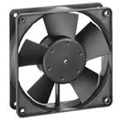
  DC Fans Axial/119x32mm/24VDC 100.1CFM/Sleeve

Type: | Brushless Axial Fan
Frame Dimensions - mm: | 119 mm L x 119 mm W x 32 mm H
Operating Supply Voltage: | 24 VDC
Airflow: | 100.1 CFM
Speed: | 2800 RPM
Bearing Type: | Sleeve
Noise: | 45 dBA
Power Rating: | 5 W
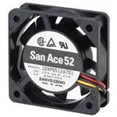
  DC Fans DC Fan 52x15mm 24VDC
  »Product Detail
  Stock:
  26 Can Ship Immediately

Product Category: | DC Fans
Manufacturer: | Sanyo Denki
RoHS:
Type: | Brushless Axial Fan
Frame Dimensions - mm: | 52 mm L x 15 mm W x 52 mm H
Operating Supply Voltage: | 24 VDC
Airflow: | 9 CFM
Speed: | 4600 RPM
Pressure Type: | 3.2 mmAq
Noise: | 27 dBA
Housing Material: | Plastic
Termination Style: | Wire Leads
Height: | 52 mm
Length: | 52 mm
Packaging: | Bulk
Product: | DC Fans
Series: | 9P
Size: | 52 mm
Width: | 15 mm
Brand: | Sanyo Denki
Current Type: | DC
Factory Pack Qty: | 100
Tradename: | San Ace
Part # Aliases: | 1408298 96M5528
Unit Weight: | 55 g

